Vulnerability Name- Insecure Remote Login (Rlogin) Service

Severity- high

Vulnerability description- The Rlogin service allows remote login and transmits usernames, passwords, and session data in plaintext. It does not provide encryption, making it vulnerable to credential theft and unauthorized access.

- Vulnerability
The Rlogin service allows remote login and transmits usernames, passwords, and session data in plaintext. It does not provide encryption, making it vulnerable to credential theft and unauthorized access.
- Attack
- Remote Login
- Unauthorized Access
- Cleartext Credential Exposure

Impacts-
- Unauthorized remote access
- Credential interception
- Full system compromise if root login is allowed
Steps to reproduce-
  - Scan the target and identify that the Rlogin (TCP Port 513) service is running.
  - Connect to the target using the Rlogin client.
  - Log in with valid credentials (or an existing trust relationship in the lab).
  - Verify successful login by obtaining the remote shell.
  - Run a simple command such as ls to confirm remote access.
Proof of concept-
- Scan for target:(nbtscan 192.168.79.129):
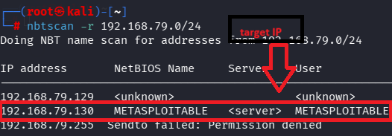
- Scan ports and services:
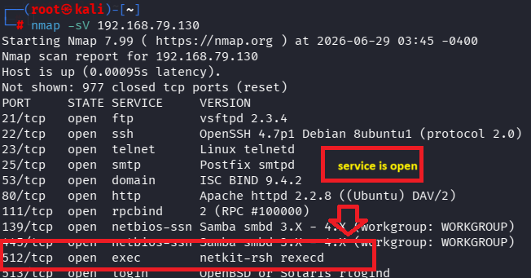
- Check rsh client is present:
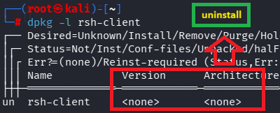
- Install rsh client :
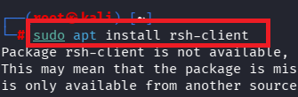
- R login in target ip (rlogin -l root ip):
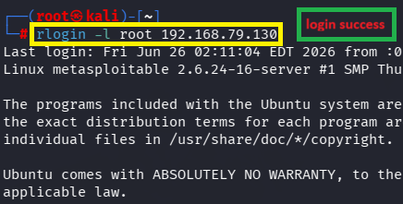
- Get excess:
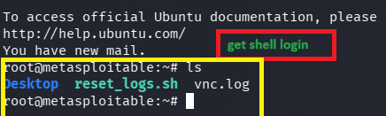

Remedy-

  - Disable the Rlogin service.
  - Use SSH instead of Rlogin.
  - Disable remote root login.
  - Restrict remote access with a firewall.
  - Use strong authentication.
References-
https://nvd.nist.gov/vuln/detail/CVE-2007-2447?utm_source=chatgpt.com
https://nvd.nist.gov/vuln/detail/CVE-2007-2447?utm_source=chatgpt.com

